Agenda- Display the assignments that crossed the deadline in a report for a particular case type

Create one report under the case type class which you want to show and then go for the usage of the joins

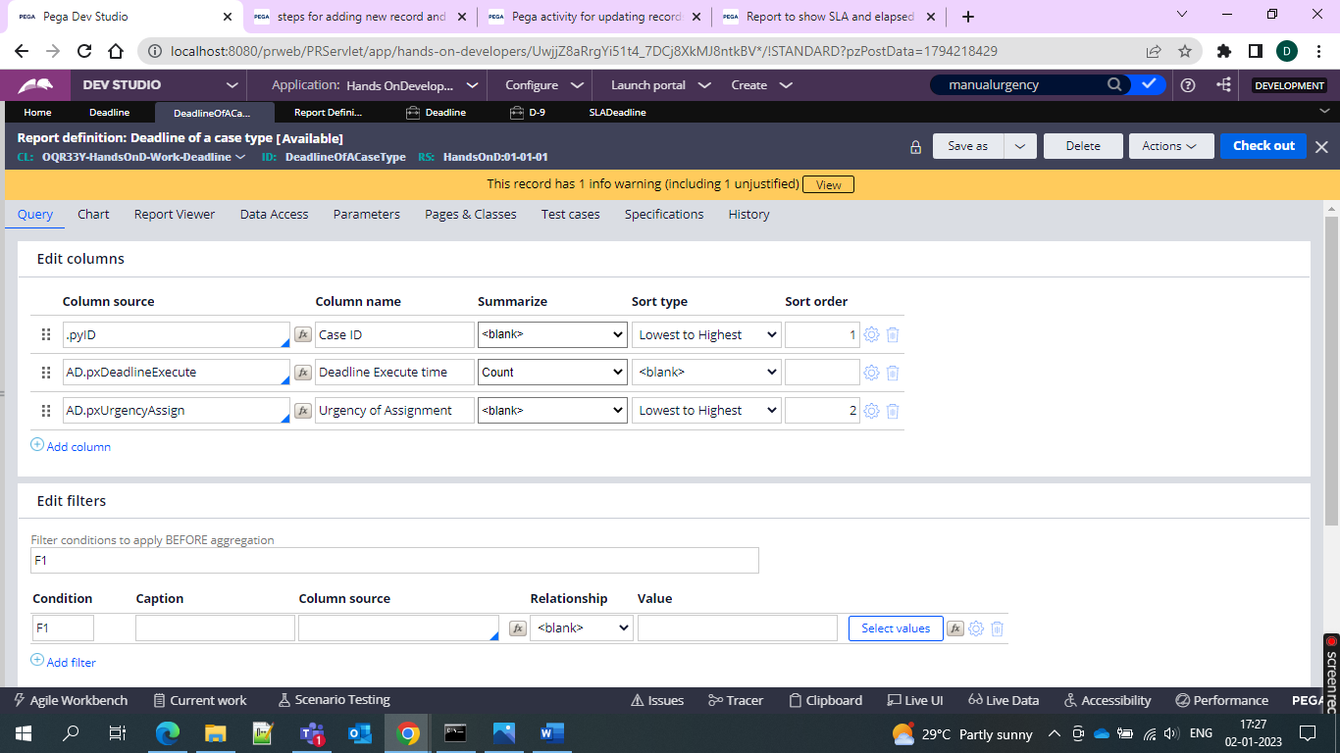

And in the join condition give as follows

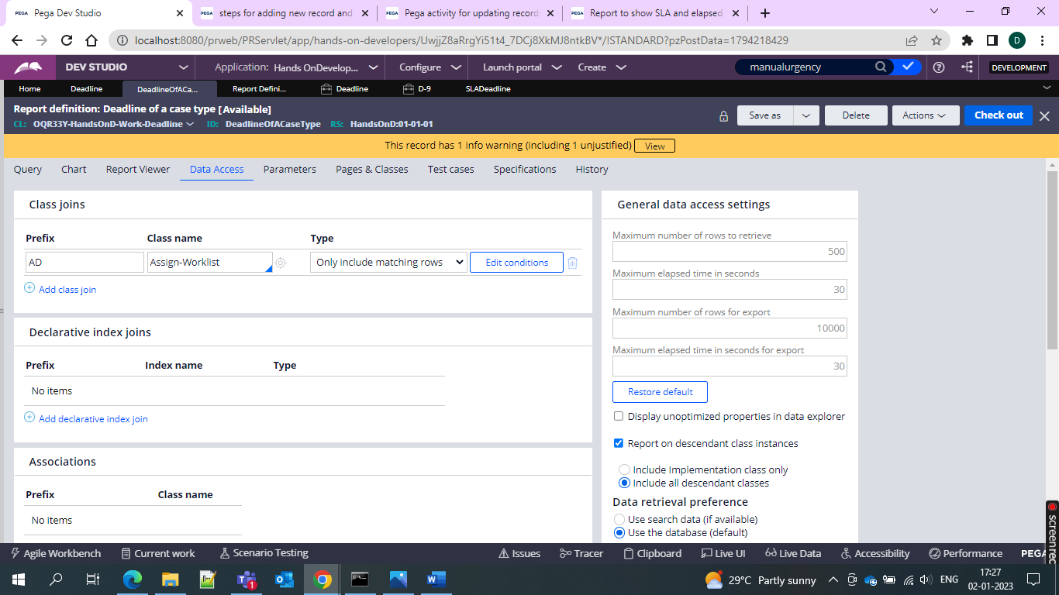

And in that give the filter condition give as below 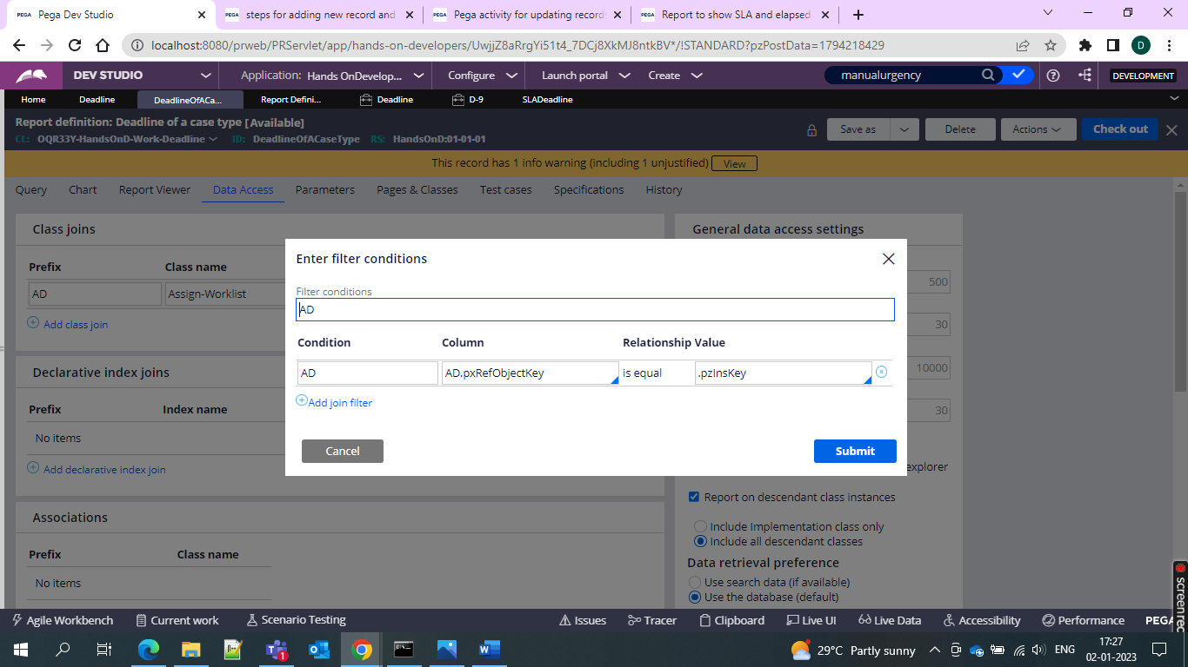

And then go for the run of the report

So total out of 9 only 5 have passed the deadline

